1)SELECT *

FROM Emp

WHERE EXTRACT(YEAR FROM SYSDATE) - EXTRACT(YEAR FROM Hire_Date) > 2;

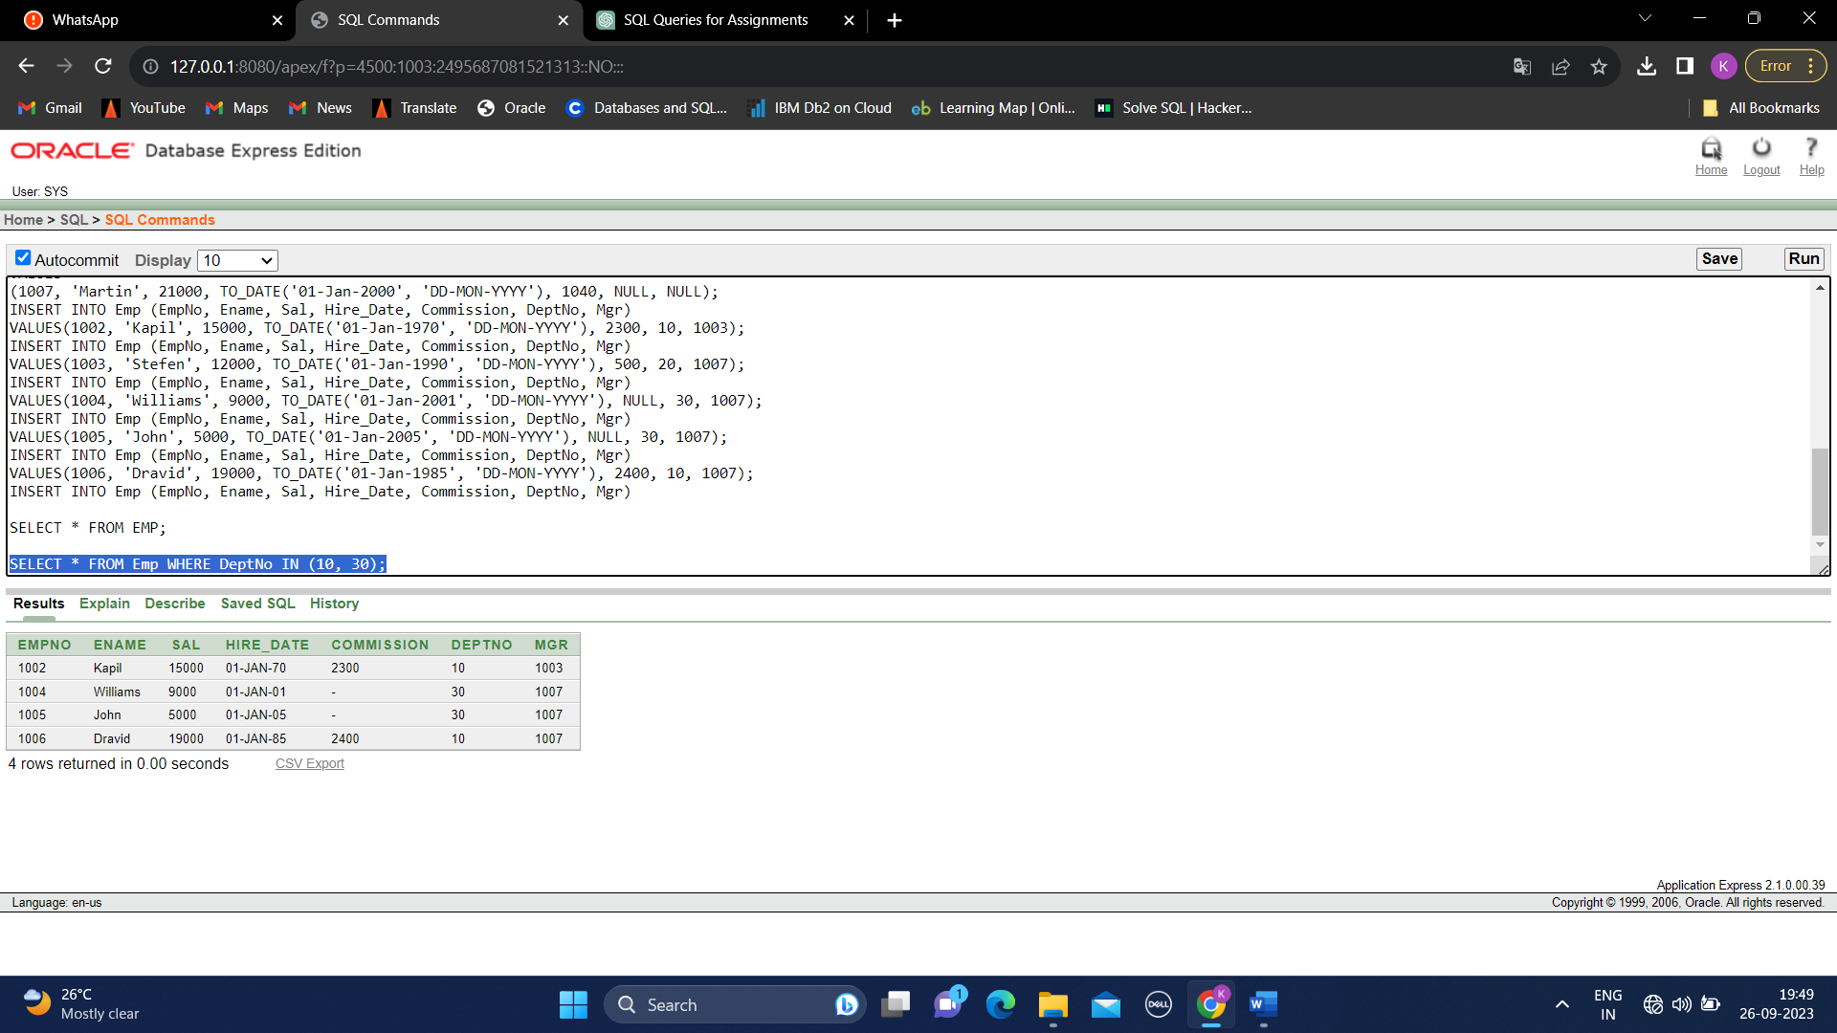

2)SELECT REPLACE(Ename, 'a', '#') AS EmployeeName

FROM Emp;

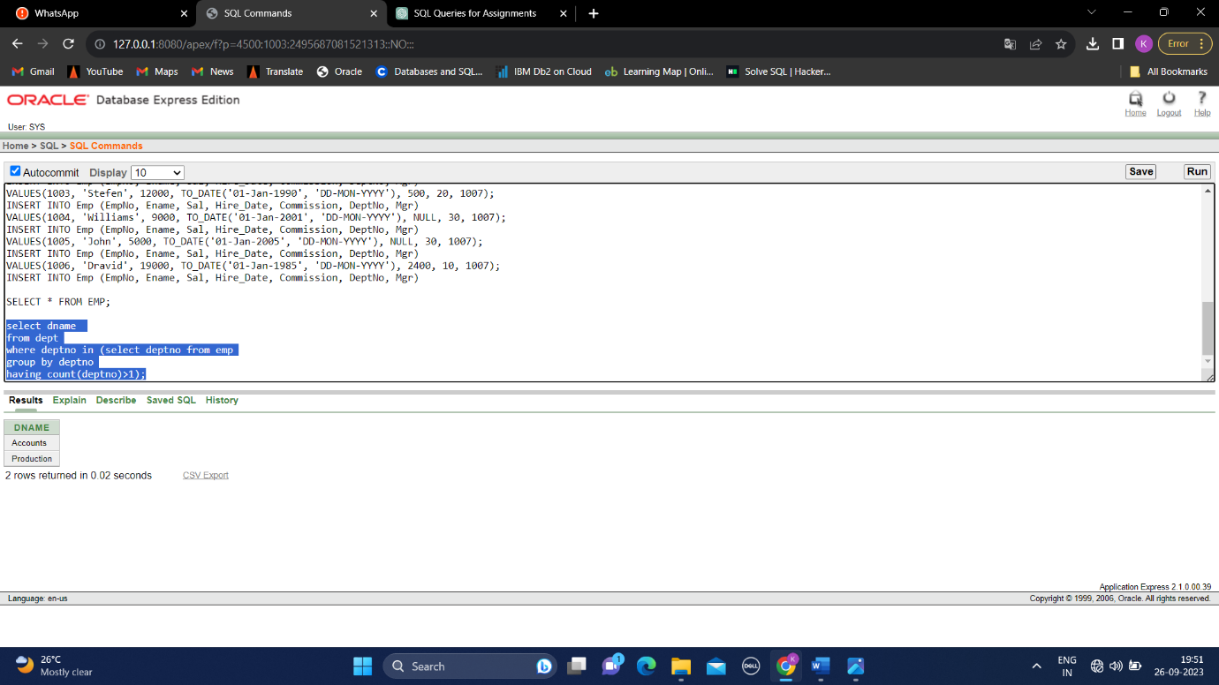

3)SELECT E.Ename AS EmployeeName, M.Ename AS ManagerName

FROM Emp E

JOIN Emp M ON E.Mgr = M.EmpNo

WHERE E.DeptNo = 20;

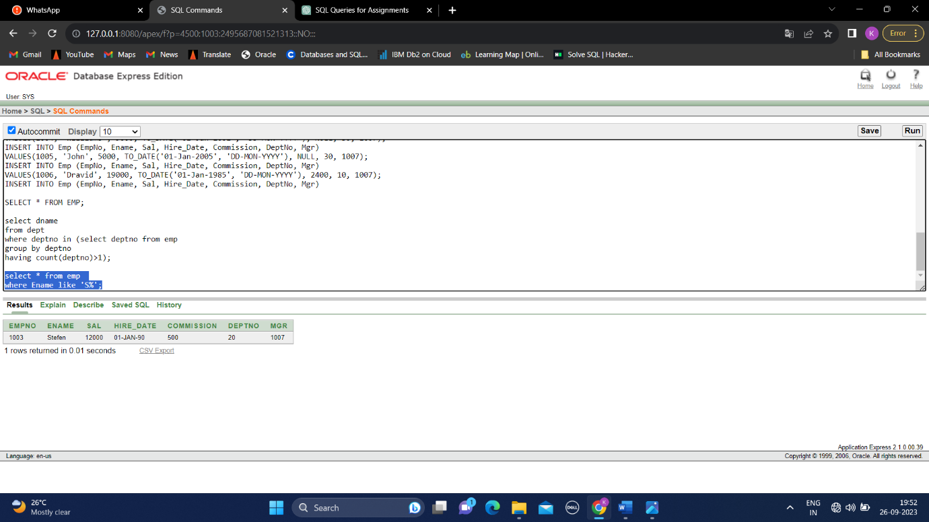

4)SELECT D.Dname, SUM(E.Sal) AS TotalSalary

FROM Emp E

JOIN Dept D ON E.DeptNo = D.DeptNo

GROUP BY D.Dname;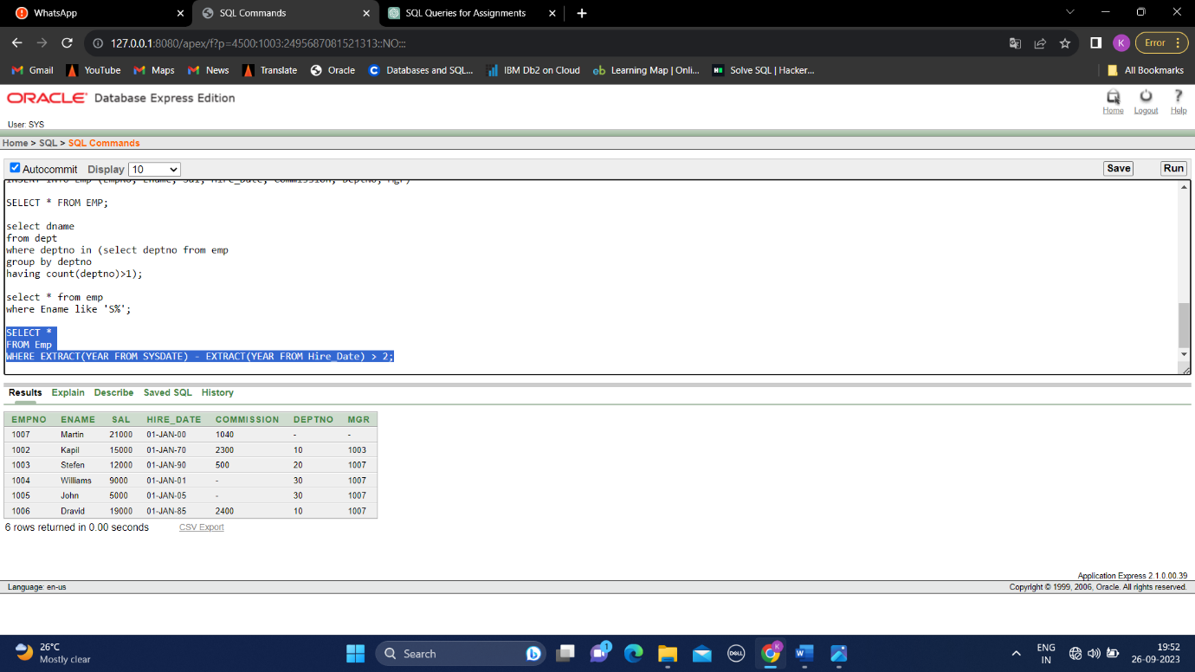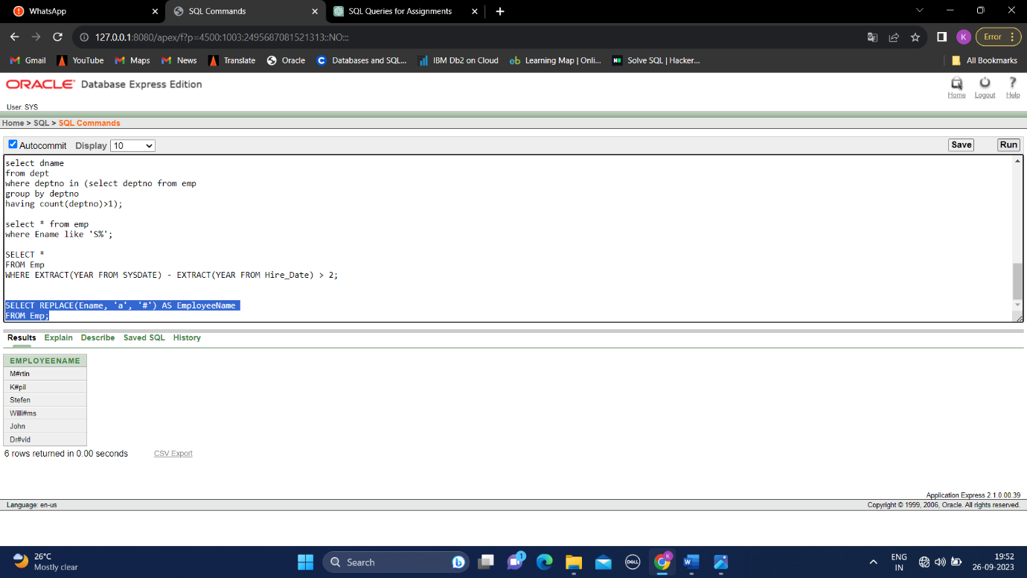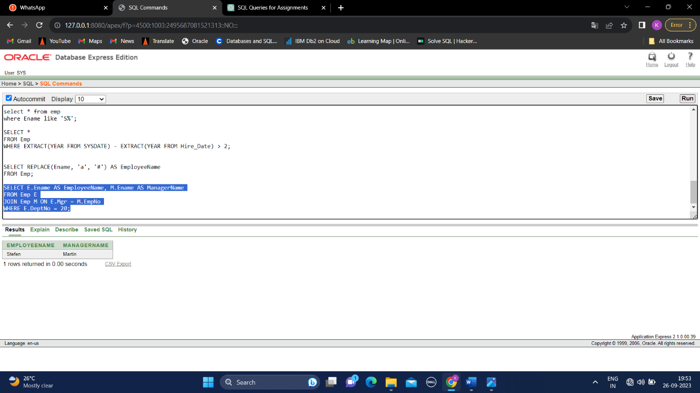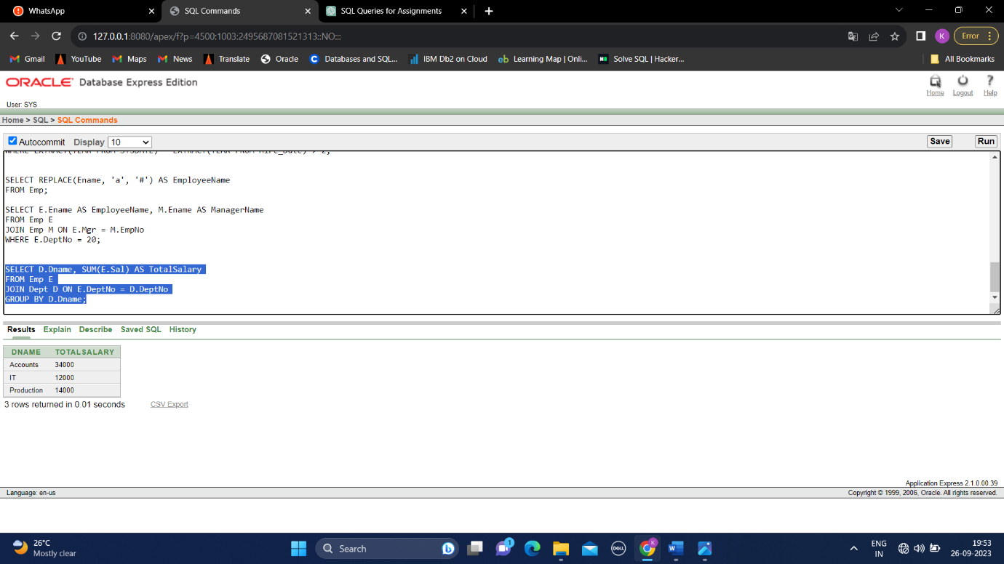

8) Write a query to fetch ALL the employee details along with department name, department location, irrespective of employee existance in the department.

SELECT E.Ename, D.Dname, D.Loc

FROM Emp E

LEFT JOIN Dept D ON E.DeptNo = D.DeptNo;

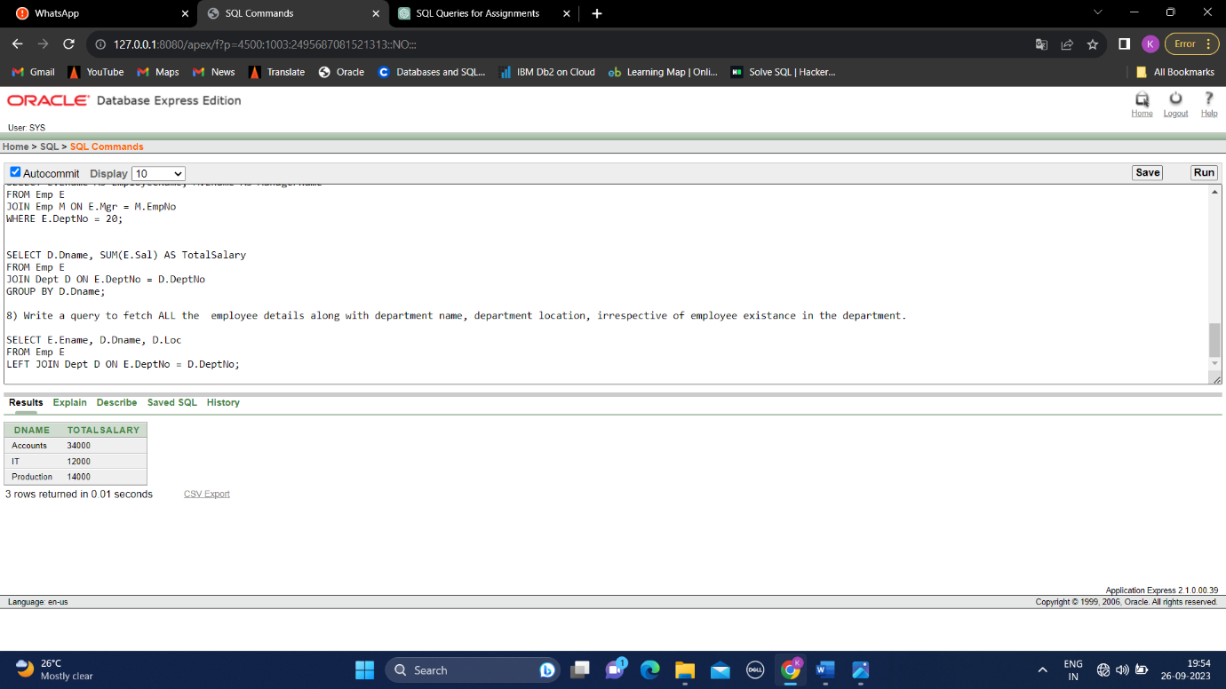

9) Write an update statement to increase the employee salary by 10 %

UPDATE Emp

SET Sal = Sal * 1.1;

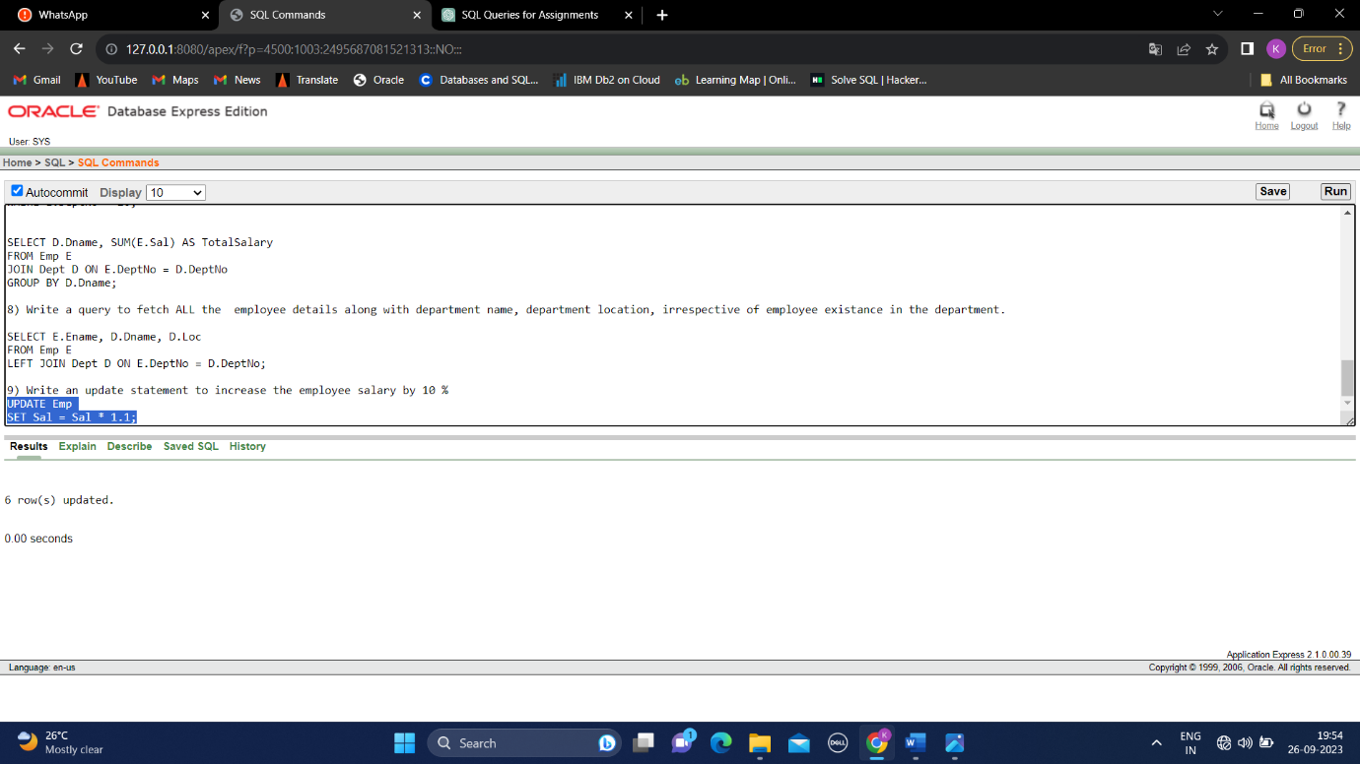

10) Write a statement to delete employees belong to Chennai location.

DELETE FROM Emp WHERE DeptNo IN (SELECT DeptNo FROM Dept WHERE Loc = 'Chennai');

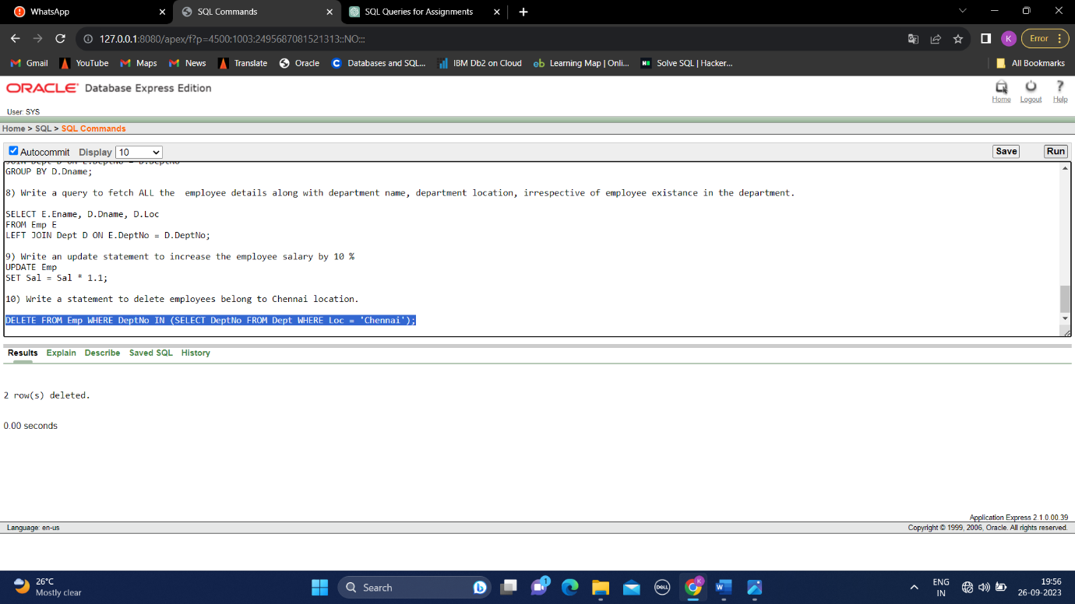

11) Get Employee Name and gross salary (sal + commission) .

SELECT Ename, Sal + Commission AS GrossSalary

FROM Emp;

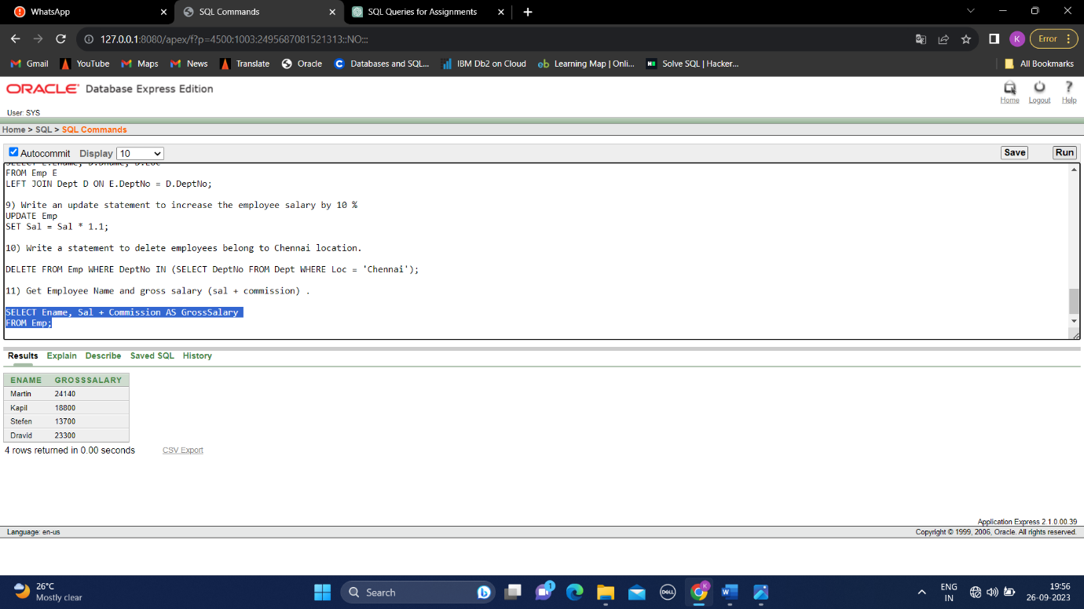

12)Increase the data length of the column Ename of Emp table from 100 to 250 using ALTER statement.

ALTER TABLE Emp MODIFY Ename VARCHAR(255);

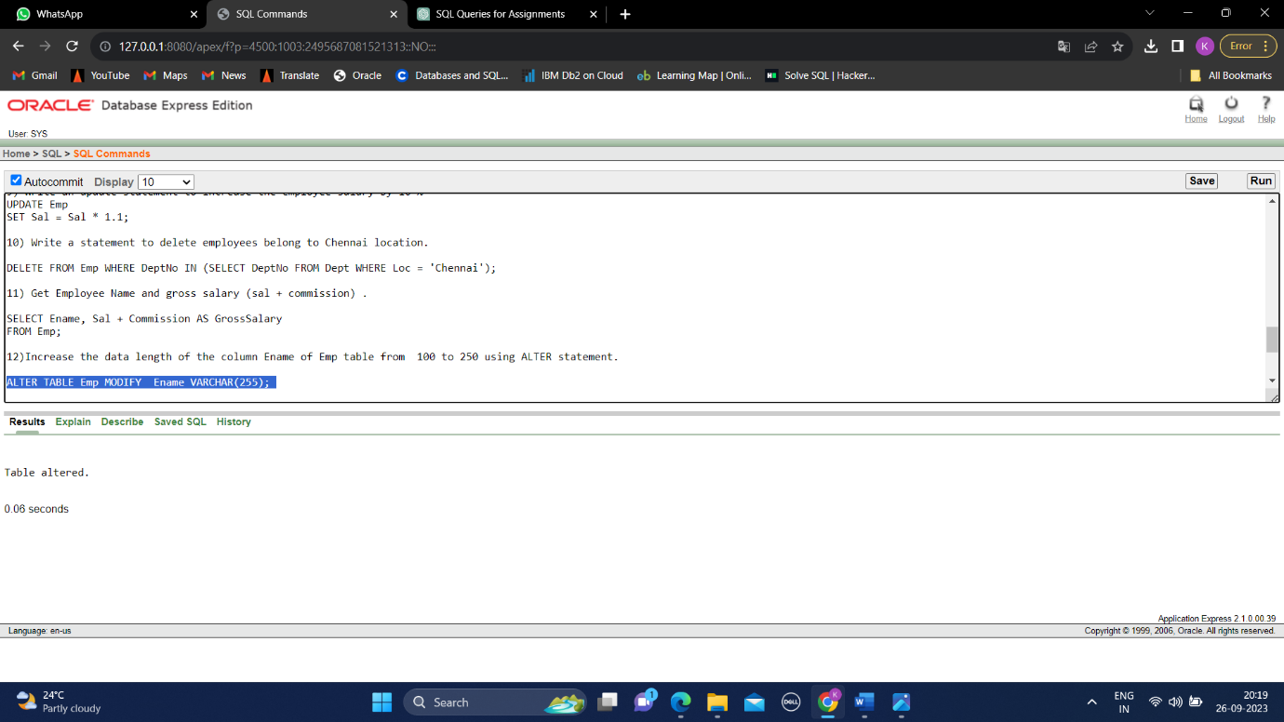

13)Write query to get current datetime

SELECT TO_CHAR(CURRENT_DATE,'DD-MM-YYYY HH24:MI:SS') AS DATETIME FROM DUAL;

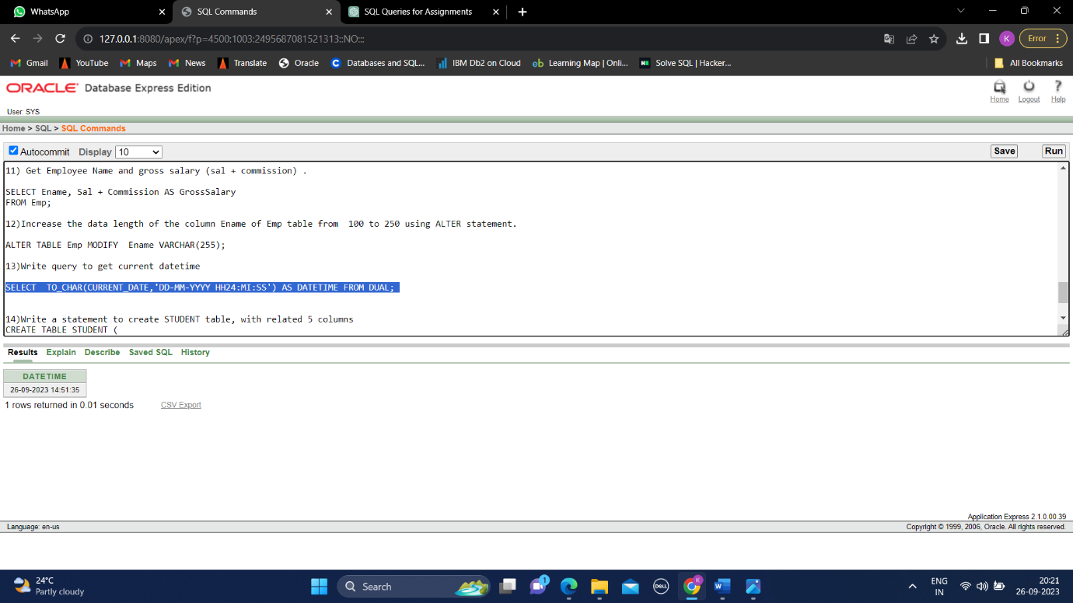

14)Write a statement to create STUDENT table, with related 5 columns

CREATE TABLE STUDENT1 (

StudentId INT NOT NULL ,

FirstName VARCHAR(255) NOT NULL,

LastName VARCHAR(255) NOT NULL,

DOB DATE,

Grade INT NOT NULL,

PRIMARY KEY (StudentId)

);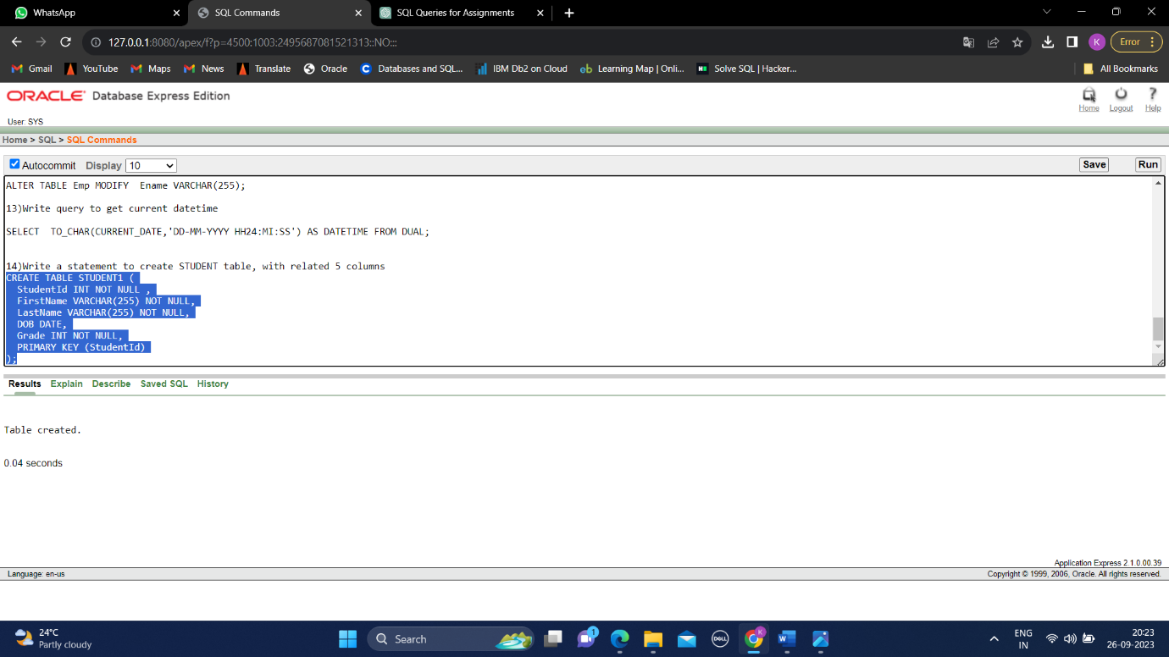

16)Write a query to fetch number of employees in who is getting salary more than 10000

SELECT COUNT(*) AS NumEmployees

FROM Emp

WHERE Sal > 10000;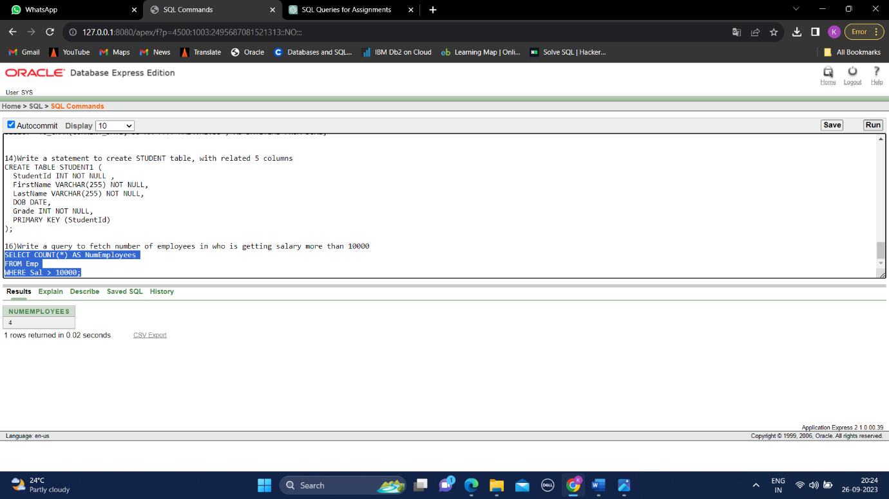

17)Write a query to fetch minimum salary, maximum salary and average salary from emp table.

SELECT MIN(Sal) AS MinSalary, MAX(Sal) AS MaxSalary, AVG(Sal) AS AvgSalary

FROM Emp

WHERE DeptNo = 20;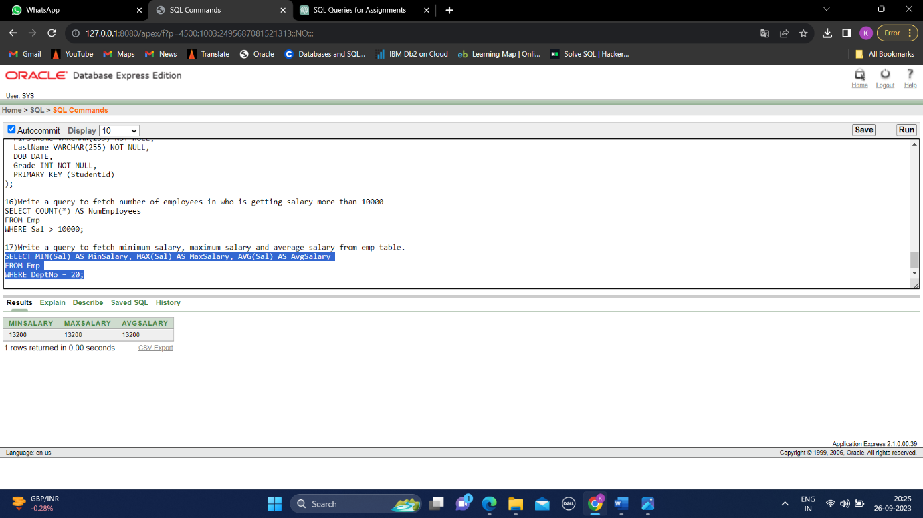

18)Write a query to fetch number of employees in each location

SELECT ENAME

FROM Emp

ORDER BY ENAME DESC;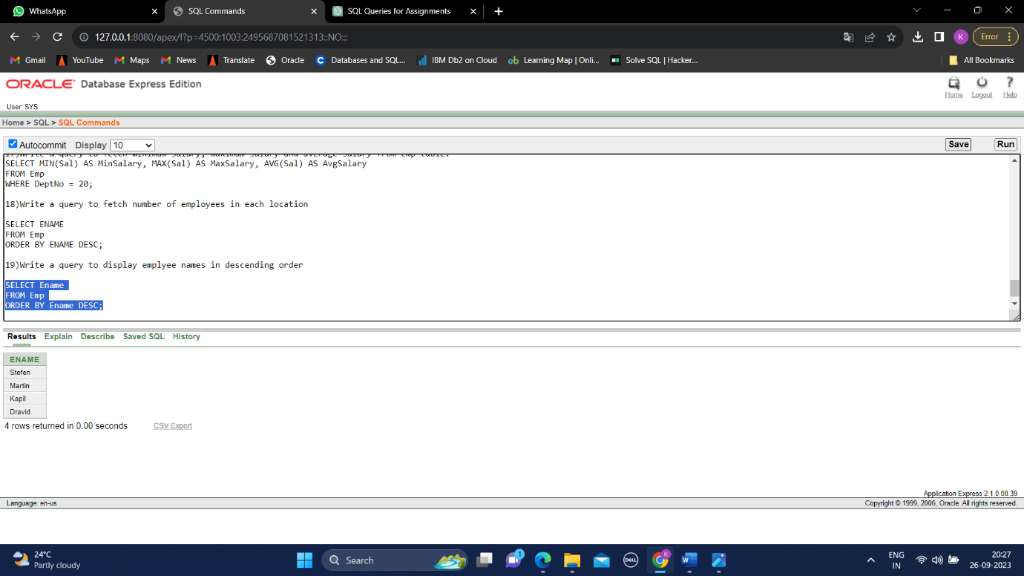

19)Write a query to display emplyee names in descending order

SELECT Ename

FROM Emp

ORDER BY Ename DESC;

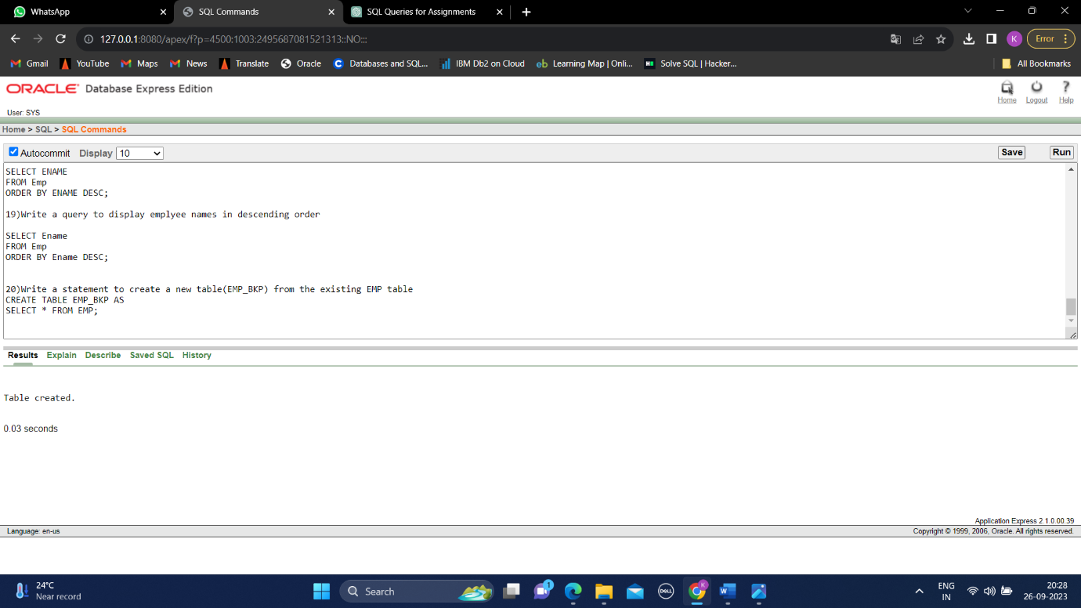

20)Write a statement to create a new table(EMP_BKP) from the existing EMP table

CREATE TABLE EMP_BKP AS

SELECT * FROM EMP;

21)Write a query to fetch first 3 characters from employee name appended with salary.

SELECT CONCAT(SUBSTR(Ename, 0, 3), Sal) FROM

Emp;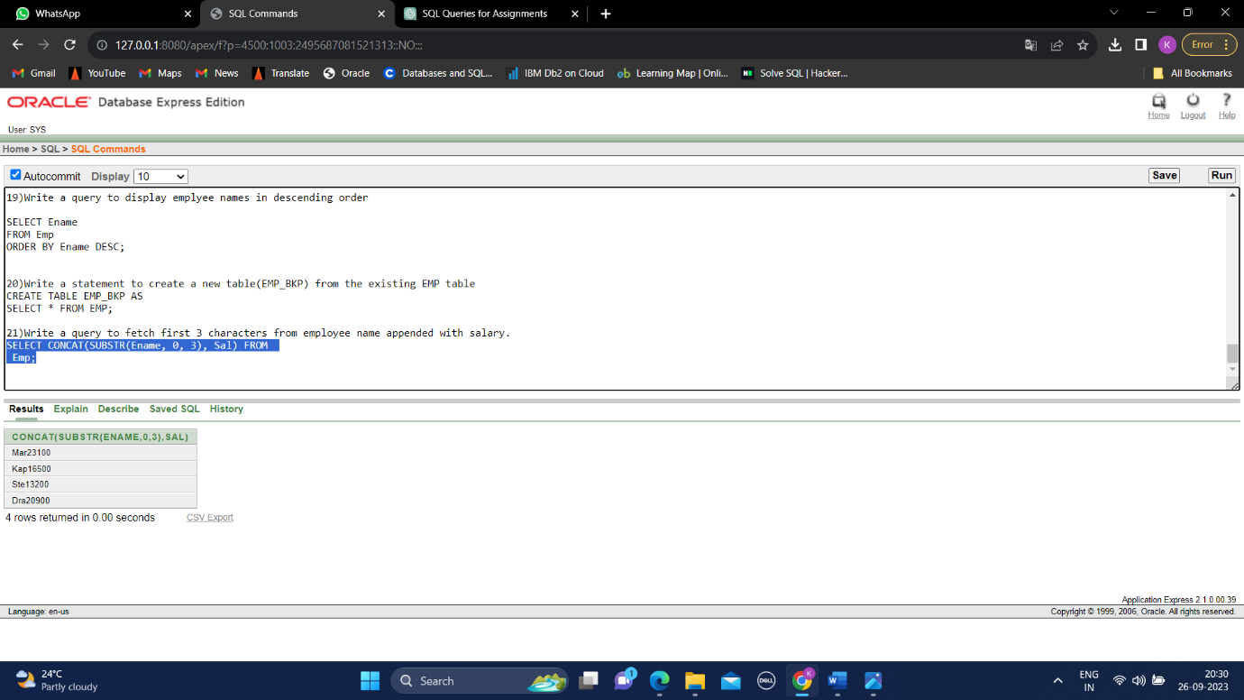

21)Get the details of the employees whose name starts with S

SELECT * FROM Emp WHERE Ename LIKE 'S%';

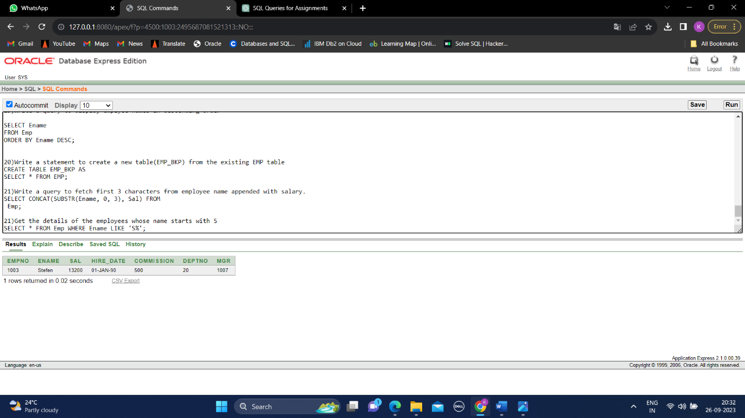

22) Get the details of the employees who works in Bangalore location

SELECT * FROM Emp E,DEPT D

WHERE D.DEPTNO=E.DEPTNO AND Loc = 'Bangalore';

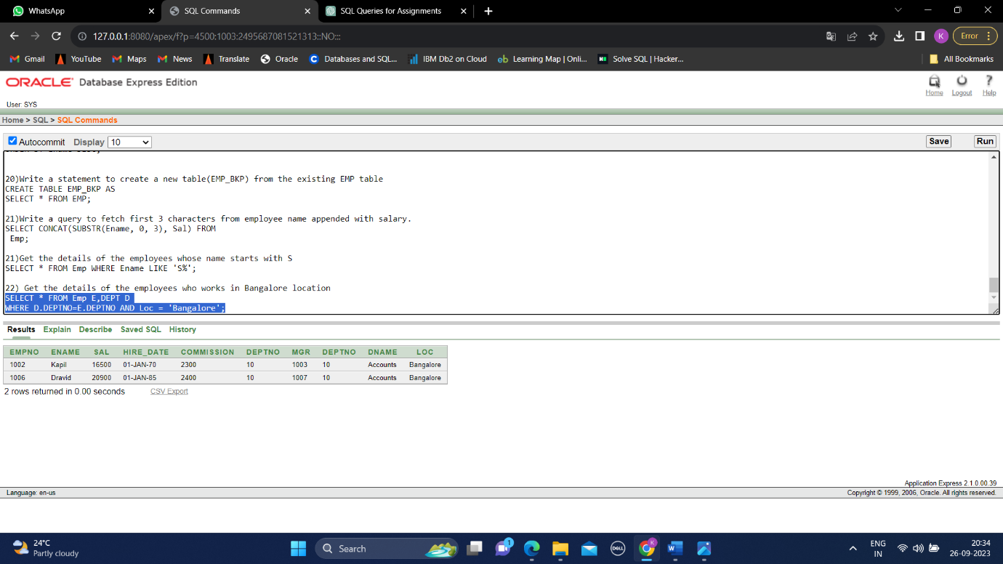

23) Write the query to get the employee details whose name started within any letter between A and K

SELECT * FROM Emp WHERE Ename LIKE '[A-K]%';

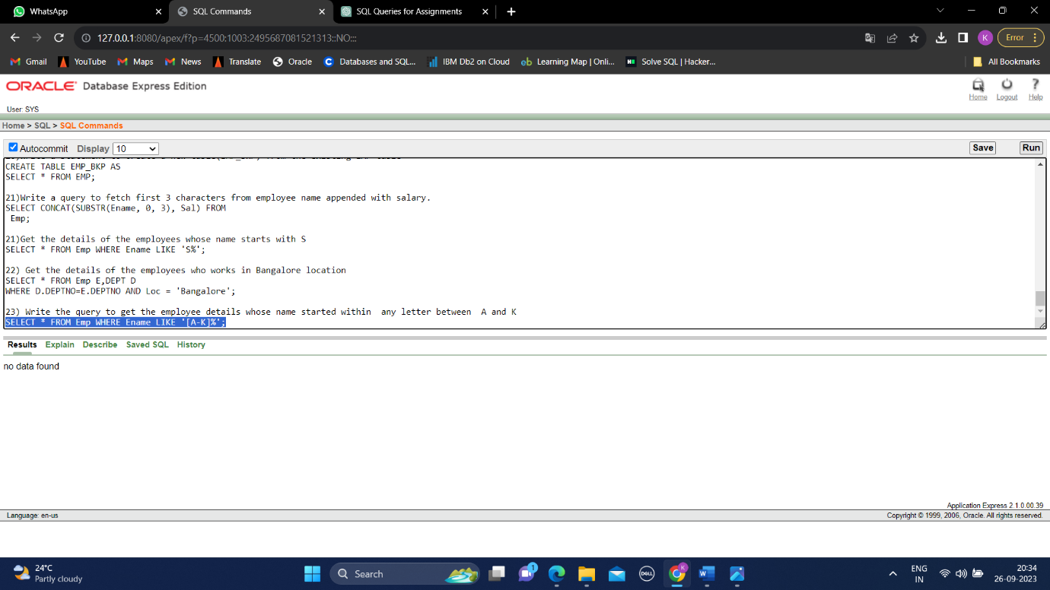

24)Write a query in SQL to display the employees whose manager name is Stefen

SELECT E.*,M.ENAME AS MANAGER_NAME

FROM Emp E,EMP M

WHERE M.ENAME='Stefen' AND E.Mgr = M.EMPNO ;

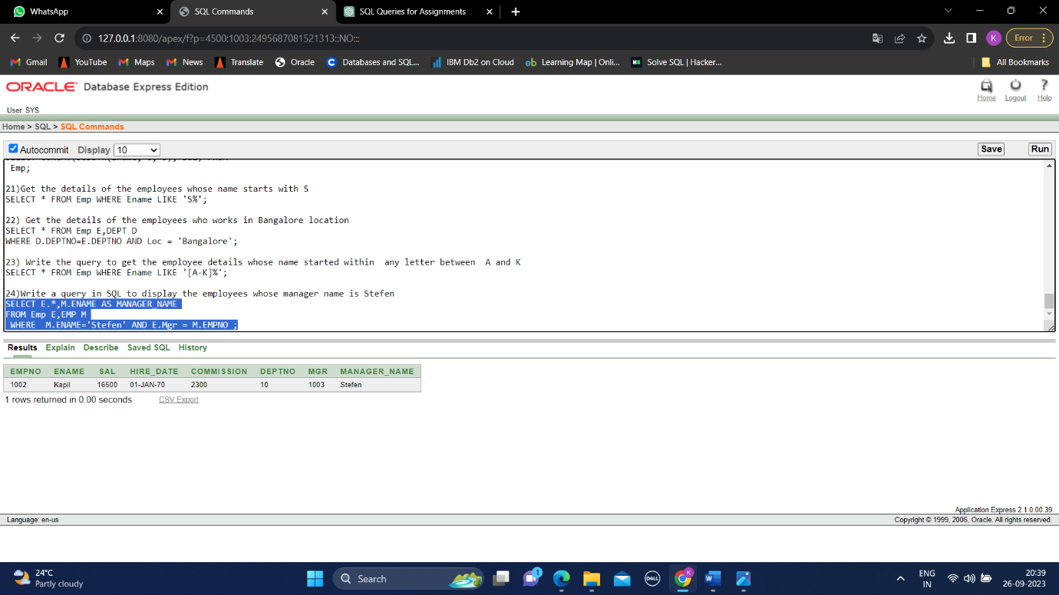

25) Write a query in SQL to list the name of the managers who is having maximum number of employees working under him

SELECT ename from emp

where empno in (select mgr from(select mgr,count(mgr) as aaa from emp

group by (mgr)

having count(*)=(select max(ct) from (select count(mgr) as ct

from emp

group by (mgr)))));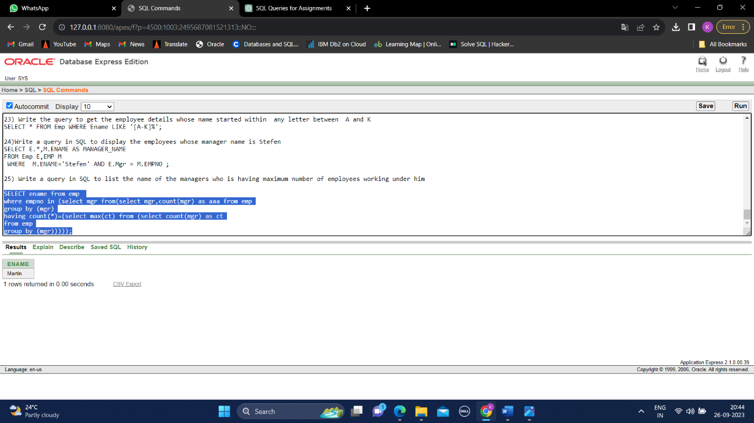

26) Write a query to display the employee details, department details and the manager details of the employee who has second highest salary

SELECT e.*, m.Ename, d.*

FROM Emp e,emp m,dept d

where d.deptno=e.deptno and e.empno=m.empno and e.empno in(

select empno from emp where sal=(select max(sal) from emp

where empno!=(select empno from emp

where sal=(select max(sal) from emp))))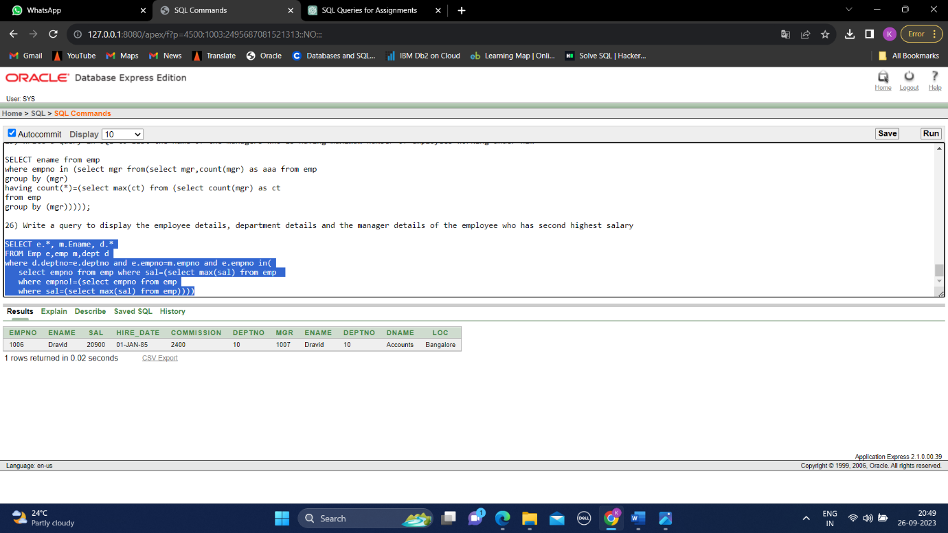

27) Write a query to list all details of all the managers

SELECT *

FROM Emp

WHERE Mgr IS NULL;

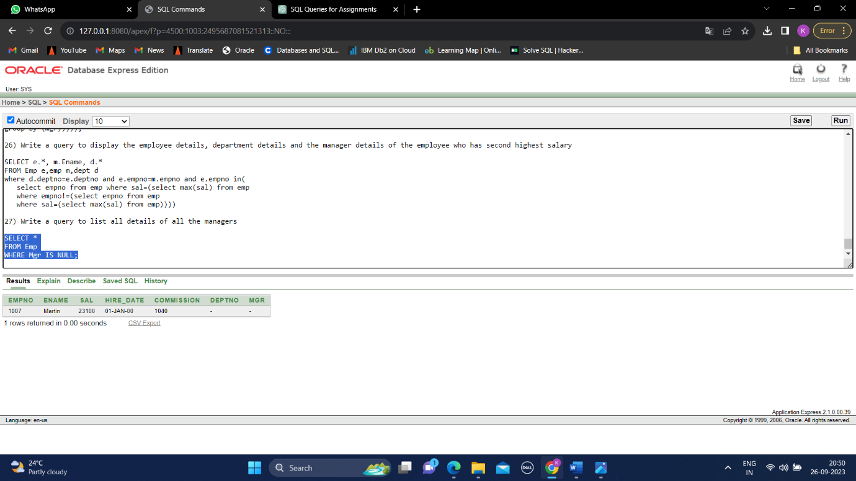

28) Write a query to list the details and total experience of all the managers

SELECT m.*, round(months_between(current_date,hire_date)/12,2) as experience

from emp m

where empno in( select mgr from emp);

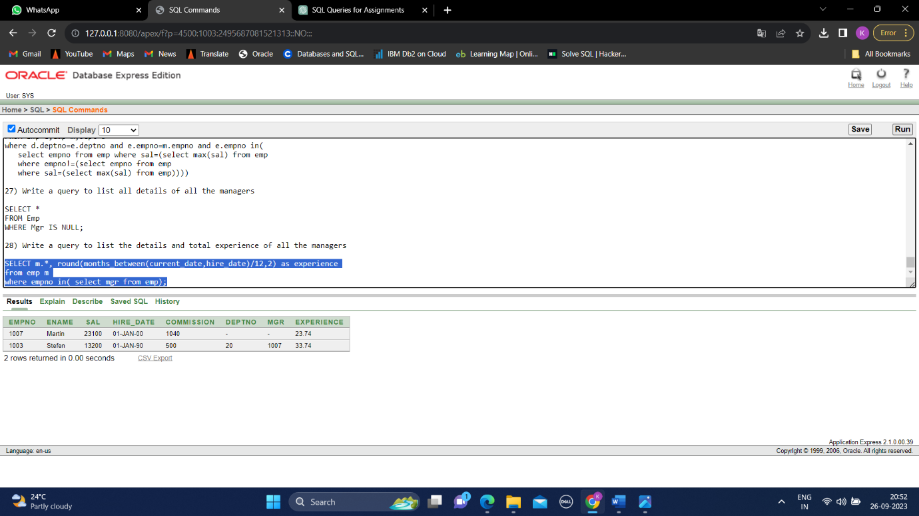

29) Write a query to list the employees who is manager and takes commission less than 1000 and works in Delhi

SELECT *

FROM Emp

WHERE commission<1000 and deptno in( select deptno from dept where loc='Delhi') and

empno in (select mgr from emp);

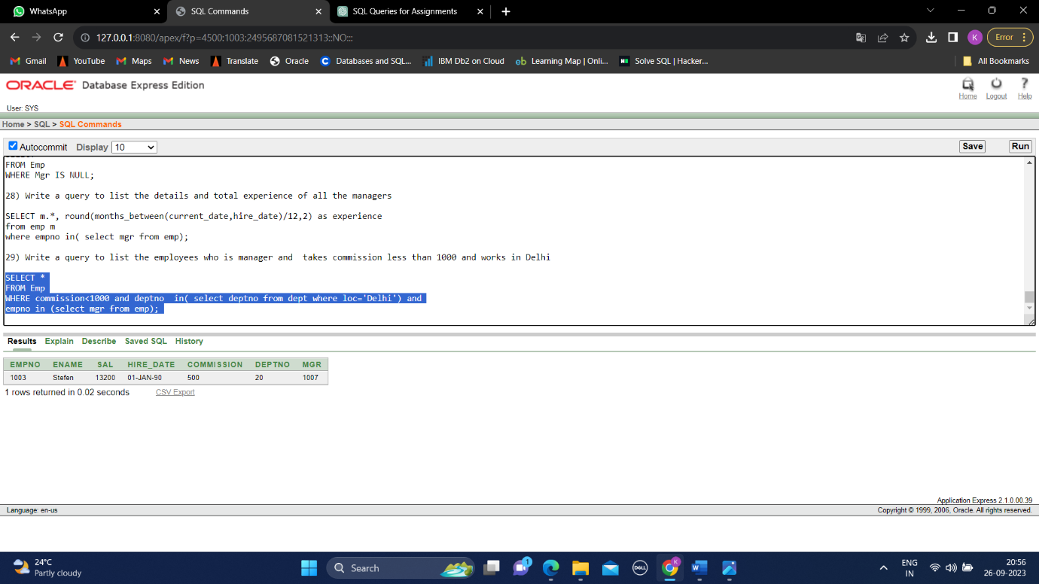

30) Write a query to display the details of employees who are senior to Martin

SELECT *

FROM Emp

WHERE Hire_Date < (SELECT Hire_Date FROM Emp WHERE Ename = 'Martin');

